**Data Science, Data Analysis, Data Engineering and Analytical Engineering**

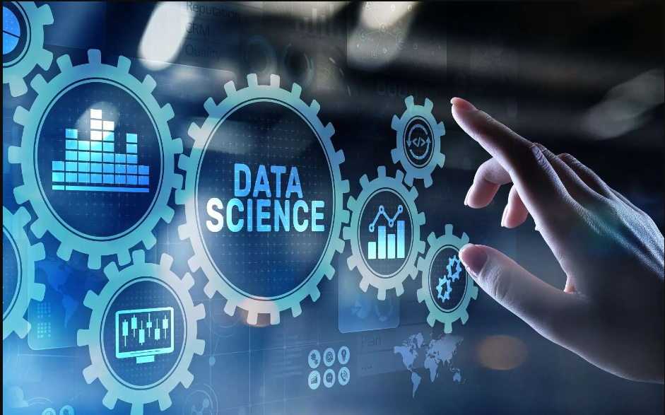

**Data** is the new gold and research done The Economist recently called data the world's most valuable resource and now; let’s see major fields related to data specialization covering Data Science, Data Analysis, Data Engineering and Analytics Engineering with **roadmap in Data Science**.

**Data Science** – This is a field of study that combines domain expertise, programming skills and knowledge of mathematics and statistics to extract meaningful insights from data. Data Science is a new field in that its existence paved in the way from the late 1980 and around 2015, this lucrative and promising field gained popularity and few years later; it became a very popular and regarded among high – paying industry.

Regarding data – this applies to all field, the stages are: capture, maintain, process, analyze communicate. After conducting the data stages all expected now is, through data – facilitate strategic business decisions.

To build a career in Data Science an individual has either go for formal path – earning a degree in Computer Science, Business Information Technology, degree or Masters in Statistics/Mathematics, or apprenticeships, boot camps and certifications or self-taught.

***Courses and Certifications for career in Data Science***

[**IBM Data Science Professional Certificate**](https://www.coursera.org/professional-certificates/ibm-data-science) **(Coursera)**

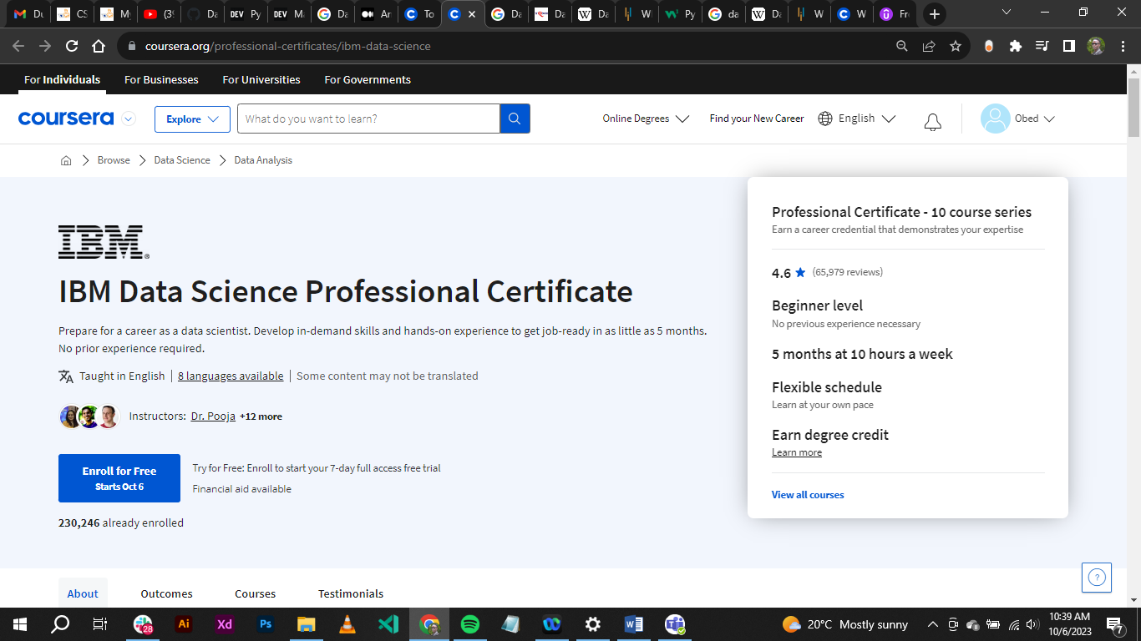

This is a beginner level if paced at **10 hours** a week will take the learner **5 months** to finish with a capstone project for their portfolio and cement the Data Science skills.

[**Data Science, Machine Learning, Data Analysis, Python & R**](https://www.udemy.com/course/data-science-machine-learning-data-analysis-python-r/?utm_source=adwords&utm_medium=udemyads&utm_campaign=DSA_Catchall_la.EN_cc.ROW&utm_content=deal4584&utm_term=_._ag_88010211481_._ad_535397282061_._kw__._de_c_._dm__._pl__._ti_dsa-392284169515_._li_1009824_._pd__._&matchtype=&gclid=CjwKCAjw4P6oBhBsEiwAKYVkqxBfMP2S4puPCJPHJfUXXnYw01zxGeghJS6-fKGLc2bFydhYkOoOYxoCXHwQAvD_BwE) **(Udemy)**

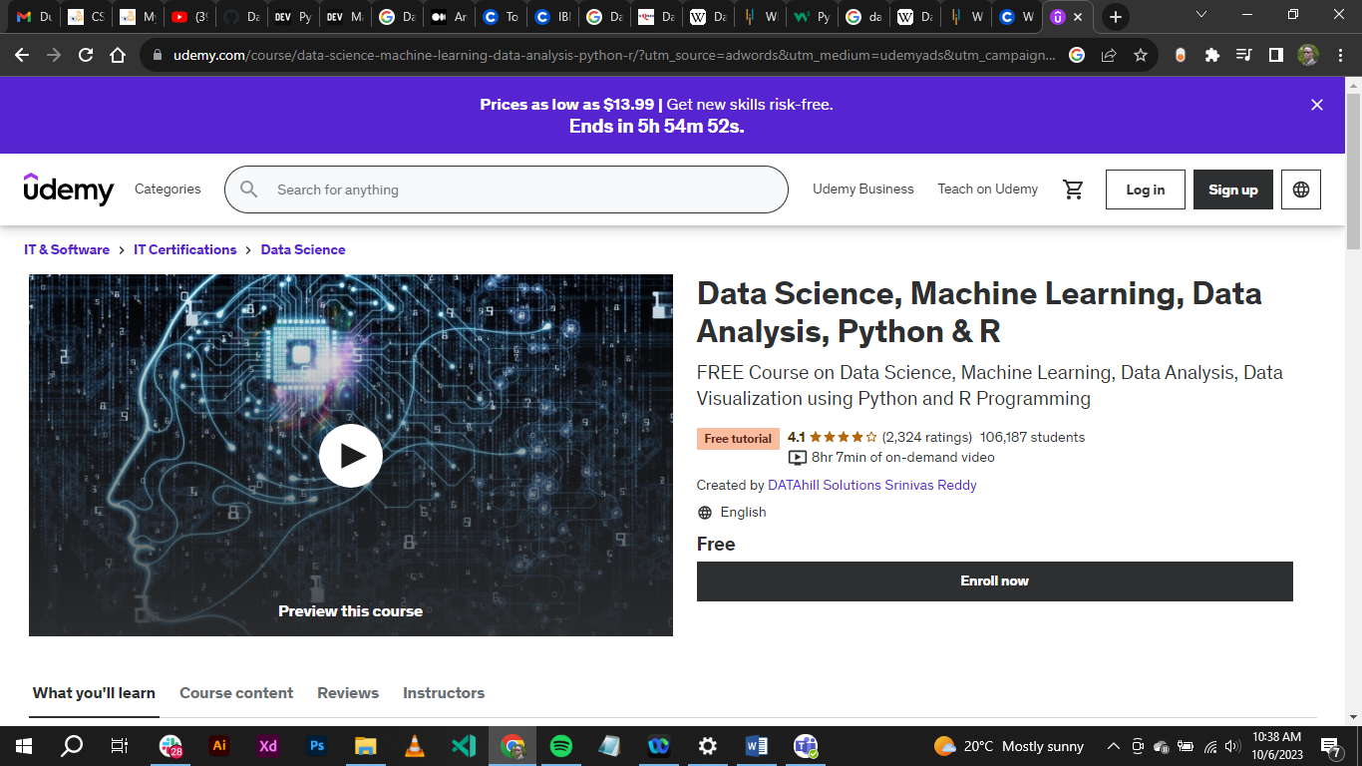

This is **free** Data Science, Machine Learning, Data Analysis, Data Visualization using Python and R Programming that the learner in **8 hours** will get the nitty gritty in Data Science and Machine Learning.

[**FreeCodeCamp**](https://www.freecodecamp.org/learn/scientific-computing-with-python/)

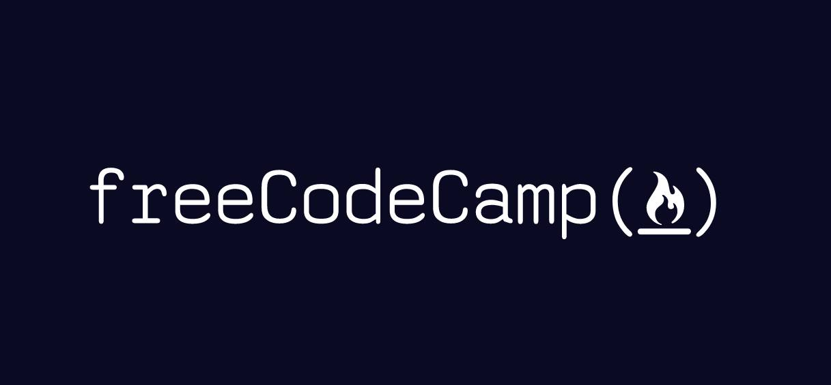

**Python for everybody** is a free video course series that teaches the basics of using Python 3.

The courses were created by Dr. Charles Severance (also known as Dr. Chuck). He is a Clinical Professor at the University of Michigan School of Information, where he teaches various technology-oriented courses including programming, database design, and web development.

This course is **self-paced**. You’ll be able to learn consistently at your own convenience.

In terms of job growth, all jobs in tech are expected to grow by **13%** over the next 10 years, that is according to **Shane Hummus** - a renown Data - content creator on YouTube: <https://youtu.be/O9nf1CqjGzI?si=2E7U8UXHAlguavqv>

A **Data Scientist** is a professional responsible for collecting, analyzing and interpreting extremely large amounts of data.

**Data Analysis** – The process of inspecting, cleansing, transforming and modeling data with the goal of discovering useful information, informing conclusions, and supporting decision-making.

Data analysis involves working with smaller, structured datasets to answer specific questions or solve specific problems.

***Courses and Certifications for career in Data Analysis***

[**Google Data Analytics**](https://www.coursera.org/professional-certificates/google-data-analytics)

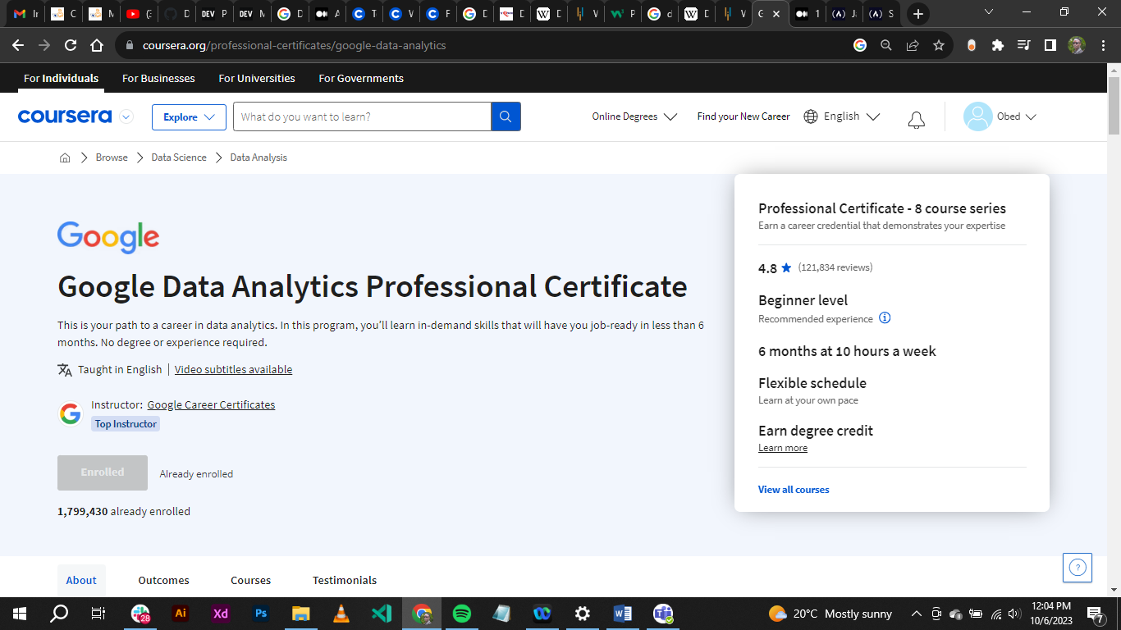

This is a **paid** course fit for new learners in the world of Data Analysis. Even though it is a paid – subscription based, good news is that it has **Financial Aid** request available to cater for those who are limited to raise the per-module cost of around **$ 39 USD.** This course covers Excel, R programming, SQL, Tableau, working with GCP – Google Cloud Platform and Foundations of Data Analysis and much more.

Majority of what is learnt by in Data Science is also covered in Data Analysis. It can be noted that a Data Scientist can only work around the dataset where a Data Analyst is not able.

A **Data Analyst** is a professional able to use statistical methods to test hypotheses and draw conclusions from the data.

**Data Engineering** – This refers to the art of designing and building systems for collecting, storing, and analyzing data at scale. It is a broad field with applications in just about every industry.

A **Data Engineer** is a professional responsible for laying the foundations for the acquisition, storage, transformation, and management of data in an organization. They manage the design, creation, and maintenance of database architecture and data processing systems; this ensures that the subsequent work of analysis, visualization, and machine learning models development can be carried out seamlessly, continuously, securely, and effectively.

**Analytics Engineering** – This is a multi-disciplinary role and can be defined as the discipline of engineering applied to the practice of analytics and big data.

An **Analytical Engineer** refers to professional who blends technical expertise with domain knowledge to craft meaningful insights from data and deliver them to users in a timely manner.

*(Separate article coming up)*

**Roadmap to Data Science**

Roadmaps refers to procedures that determine a goal or the desired outcome and feature the significant steps or milestones required to reach it.

***Learn the fundamentals of data science.***

**Programming**: Having a good knowledge in programming is a key feature to any aspiring Data Scientist. Top languages are Python and R. Choose one tool and build skills to help you do the job.

**Statistics**: Learn probability, descriptive statistics, and inferential statistics.

**Machine learning**: a subfield of Computer Science that gives computers the ability to learn without being explicitly programmed. Machine Learning is used image recognition, natural language processing, and fraud detection.

**Visualization –** When all is done with data preparation, A Data Scientist might go step ahead to create visualization using Tableau, Power BI and other industry – standard tools and softwares.

***Gain experience with data science tools***

**Python libraries**: **NumPy**, **Pandas**, **Matplotlib**, **Seaborn**, and **Scikit-learn** are some of the most popular Python libraries for Data Science. They provide a wide range of functions for data manipulation, visualization and Machine Learning.

**SQL**: Structured Query Language is used to query and manage relational databases. MySQL, PostgreSQL, and Oracle are some of the most popular SQL databases.

**Cloud computing platforms**: Cloud computing platforms like **AWS**, **Azure**, and **Google Cloud Platform** offer a variety of services for data science, such as data storage, data processing, and machine learning.

***Build a portfolio of data science projects***

* Choose projects that are challenging yet realistic.
* Document your work thoroughly – write article about the project.
* Make your code clean, reusable and concise.
* Host your projects on a public platform like GitHub.

***Network with those in the field of Data Science***

Tips for networking:

* Be active on social media platforms like LinkedIn and Twitter.
* Attend data science meetups and conferences.
* Connect with other data scientists on LinkedIn.
* Reach out to data scientists you admire and ask for advice.

***Apply for data science jobs***

Tailor your resume and cover letter to each job you apply for.

Highlight your relevant skills and experience in your resume and cover letter.

Practice answering Data Science interviews.

That is all for this work. Happy kick-start Data Science Career.